D1_Nihar_84066

ASSIGNMENT 10

1. D1_nihar_84066>select m.sname,n.sname,m.city from SALESPEOPLE m,SALESPEOPLE n where m.city=n.city and m.sname<n.sname;

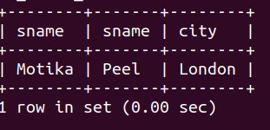

2. D1_nihar_84066>select Cname,City from CUSTOMERS where Rating= (Select Rating from CUSTOMERS where Cname="Hoffman");

